# **Product Sense -**

# How to tackle product strategy and business acumen rounds in interviews?

## **Lecture Objective:**

How to address business acumen questions round :

* Analyzing a **metric change.** What’s a metric?
* **Defining metrics** to measure performance / success of a new feature / product.

## **Importance of product strategy & business acumen rounds -**

* Apart from building models, developing dashboards and reporting frameworks - One of the main responsibilities of a data scientist is to **extract insights from data** and **work with product managers and engineering teams** to deliver actionable plans to i**mprove the product.**
* Product sense is about **understanding all possibilities**, not finding one correct answer.

## **Example Questions:** Product Acumen / Business Acumen

* Why did Youtube’s traffic drop by 5%?
* How would you measure the success of the “Save Post” feature on Facebook?
* What metrics would you define to measure the health of the product search in Amazon?
* We have a dashboard tracking our metrics and the avg ETA is up by 3 min. How would you investigate this problem?

______________________________________________________________________________

______________________________________________________________________________

## **Judgment Criteria & General Framework** -

## Keep this in mind when addressing business acumen questions.

* Judgment Criteria for Interviewers :
  + **Structure** - Demonstrate a systematic approach
  + **Comprehensiveness** - Covers all important aspects
  + **Feasibility** - Practical enough that it could be implemented realistically
* General Framework to keep in mind :
  + **Clarify**
  + **Plan**
  + **Conclude**

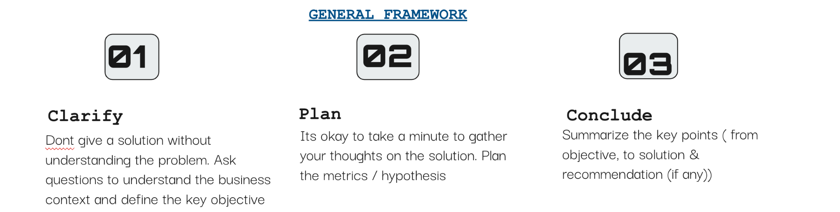

**Different Product Sense Problems** -

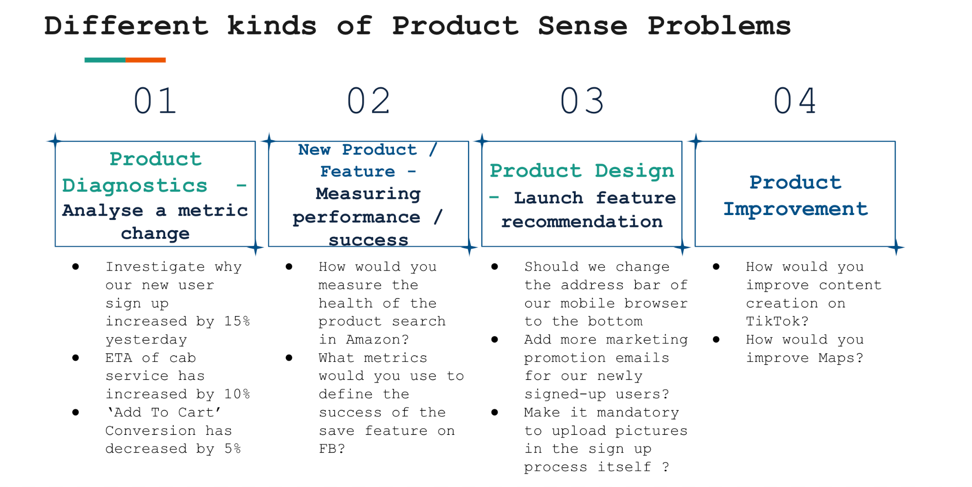

## 

## **Product Diagnostics - Analyzing a metric change.**

**Case -** You notice that the percentage of users who clicked on a search result about a Facebook Event increased 15% week-over-week. How would you investigate this?

**General Framework -**

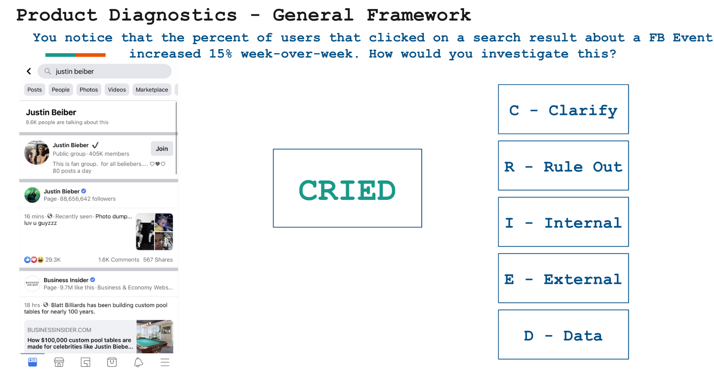

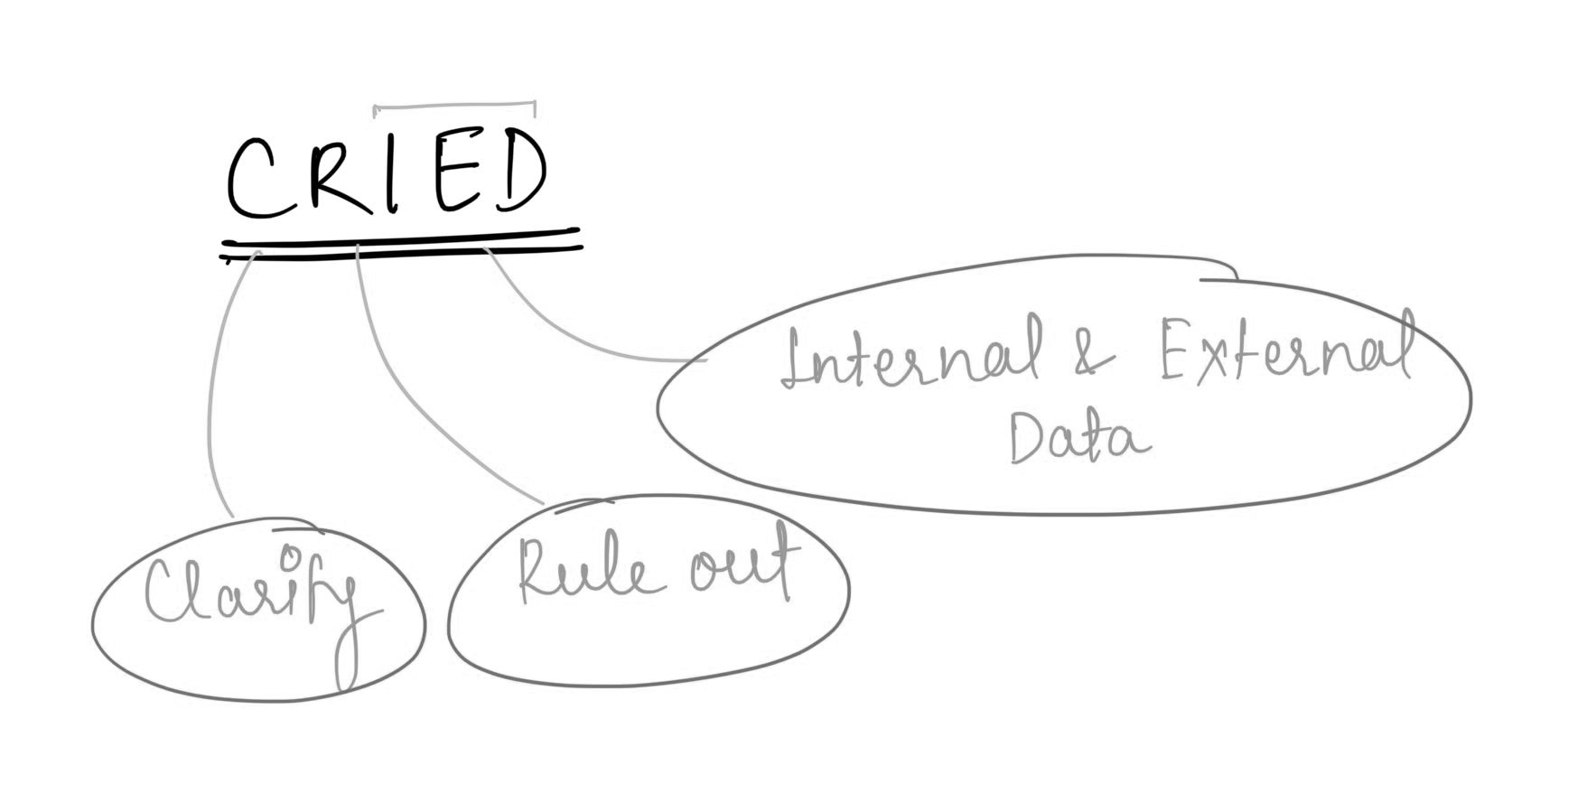

## **2. Measure Product Performance / Success - Defining metrics**

**Case -** PM reaches out to you after launch of a new save feature on Facebook to assess the success of this feature. Define the metrics you would like to measure.

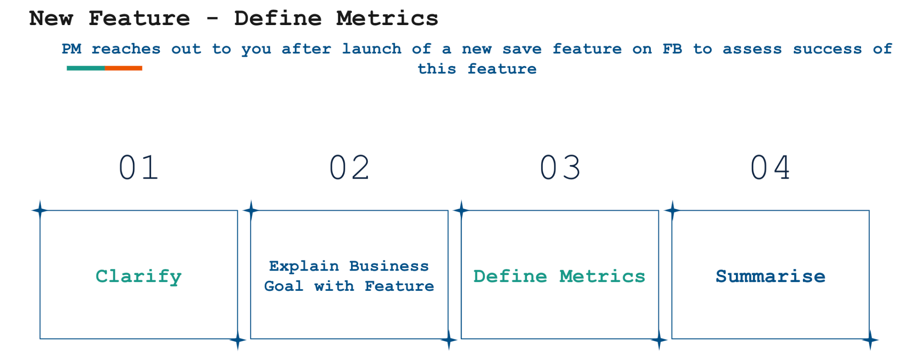

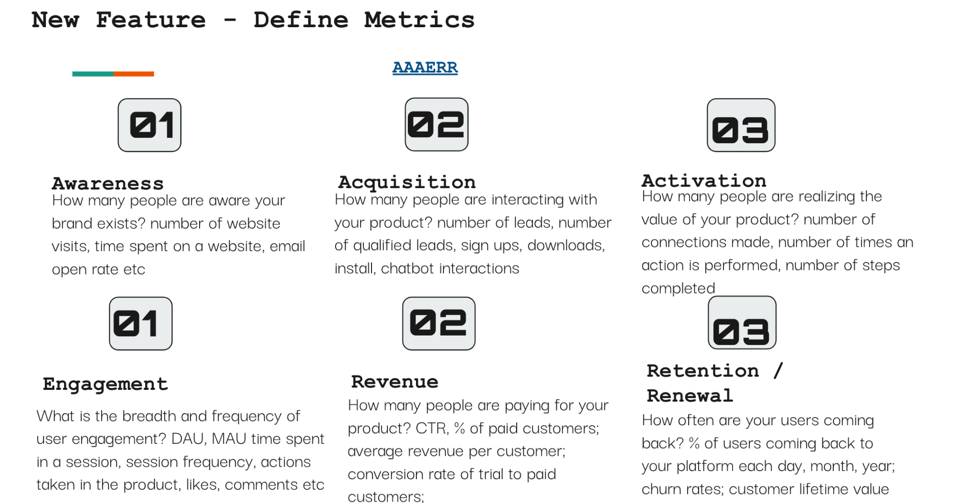

**Product Metrics**

What are product metrics?

* Product metrics are quantifiable data points that a business tracks and analyzes to evaluate the success of its product.
* By using interactive product metrics, companies can optimize product strategies to ensure business growth.
* Determining the right metrics to monitor and analyze leads to more intelligent decision-making throughout the product development process.

What are KPIs?

* These metrics, sometimes called **key performance indicators (KPIs)** can evaluate architectural measures, quality measures, software complexity, or functional size.



How do companies use these metrics?

Depending on their goals, companies may use product metrics to:

* Set their product roadmap
* Evolve product strategy
* Make changes to their product
* Forecast revenue
* Measure the impact of individual features
* Better understand user behavior
* Evaluate the success of a launch
* Segment their market
* Test product hypotheses

Why are they important from an interview perspective?

Metric definition questions come up very frequently in Data Science interviews.

These questions are generally meant to:

1. test your ability to understand the goal of a product,
2. trace the customer journey with that product and
3. map both the goal and the journey to a set of quantifiable measures.

Understanding different product metrics -

There is no fixed categorization of product metrics.

However, on a broader level, metrics are often categorized as either "**Vanity**" or "**Actionable**" based on their utility and relevance in guiding decision-making and strategy.

Now, we will look at the three labels of metrics that a company follows in order to grow :

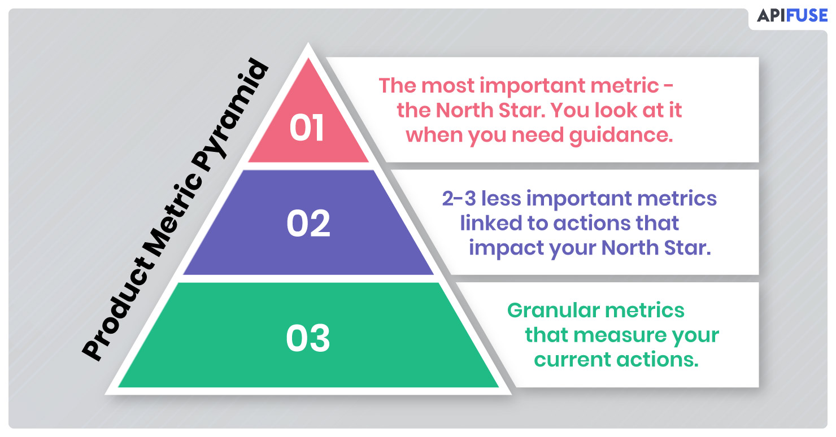

**Focus metric / North Star metric -**

This is the single most important measure of success that matters a lot to a company.

A North Star Metric (NSM) should be:

* A direct reflection of the company’s mission
* An indicator of how a company brings value to its customers.
* The only one of its kind. (Avoid having multiple NSMs as this tends to create complexity and confusion)
* The answer to the following question: What is the one metric that best represents the desired outcome of your company?

Which metric, if it were to increase today, would most accelerate my business’ flywheel?

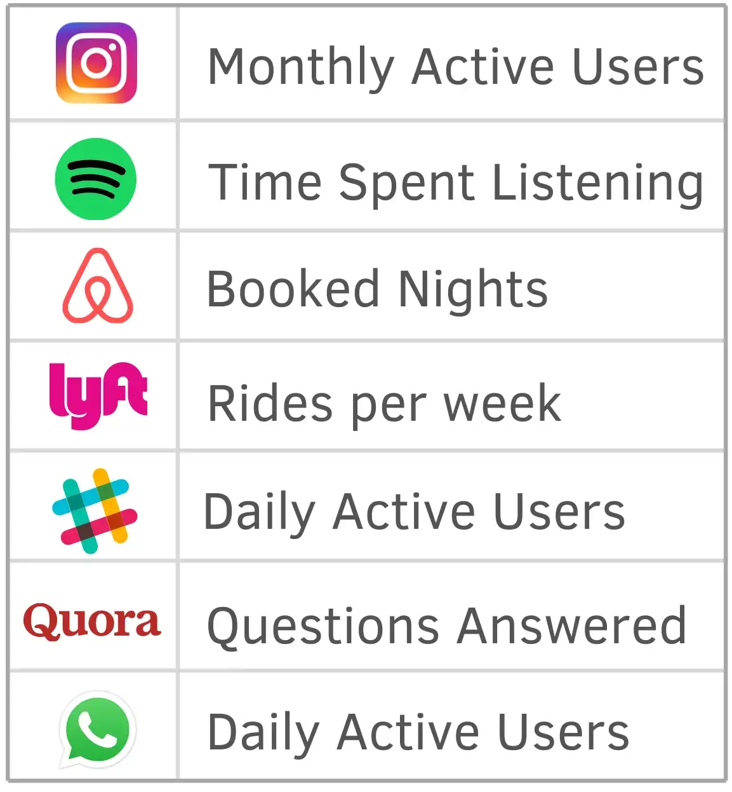

**Level 1 metric / Primary metric -**

* Primary metrics depict the desired outcome of a particular product, team, or initiative. This is unlike the NSM, which represents the desired outcome of the company as a whole.
* Level 1 (L1) or primary metrics should either directly contribute to the focus metric or act as a check to make sure the product is growing in a healthy direction.

**Supporting/ Tracking/ Input metric / Level 2 metric -**

* Performance indicators which are set for the current initiatives that are most granular and mostly used for tracking the progress at lowest level.
* For example - There may be some targeted marketing or segmented offers that need to be checked.

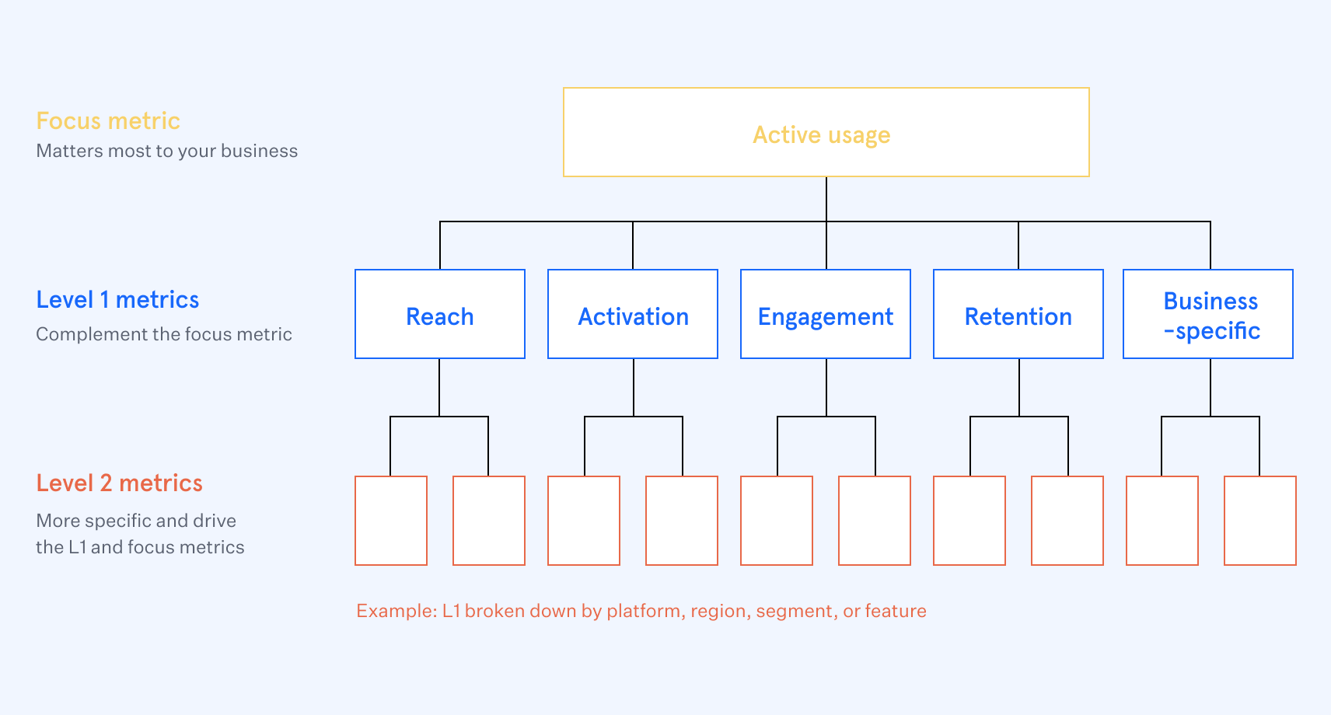

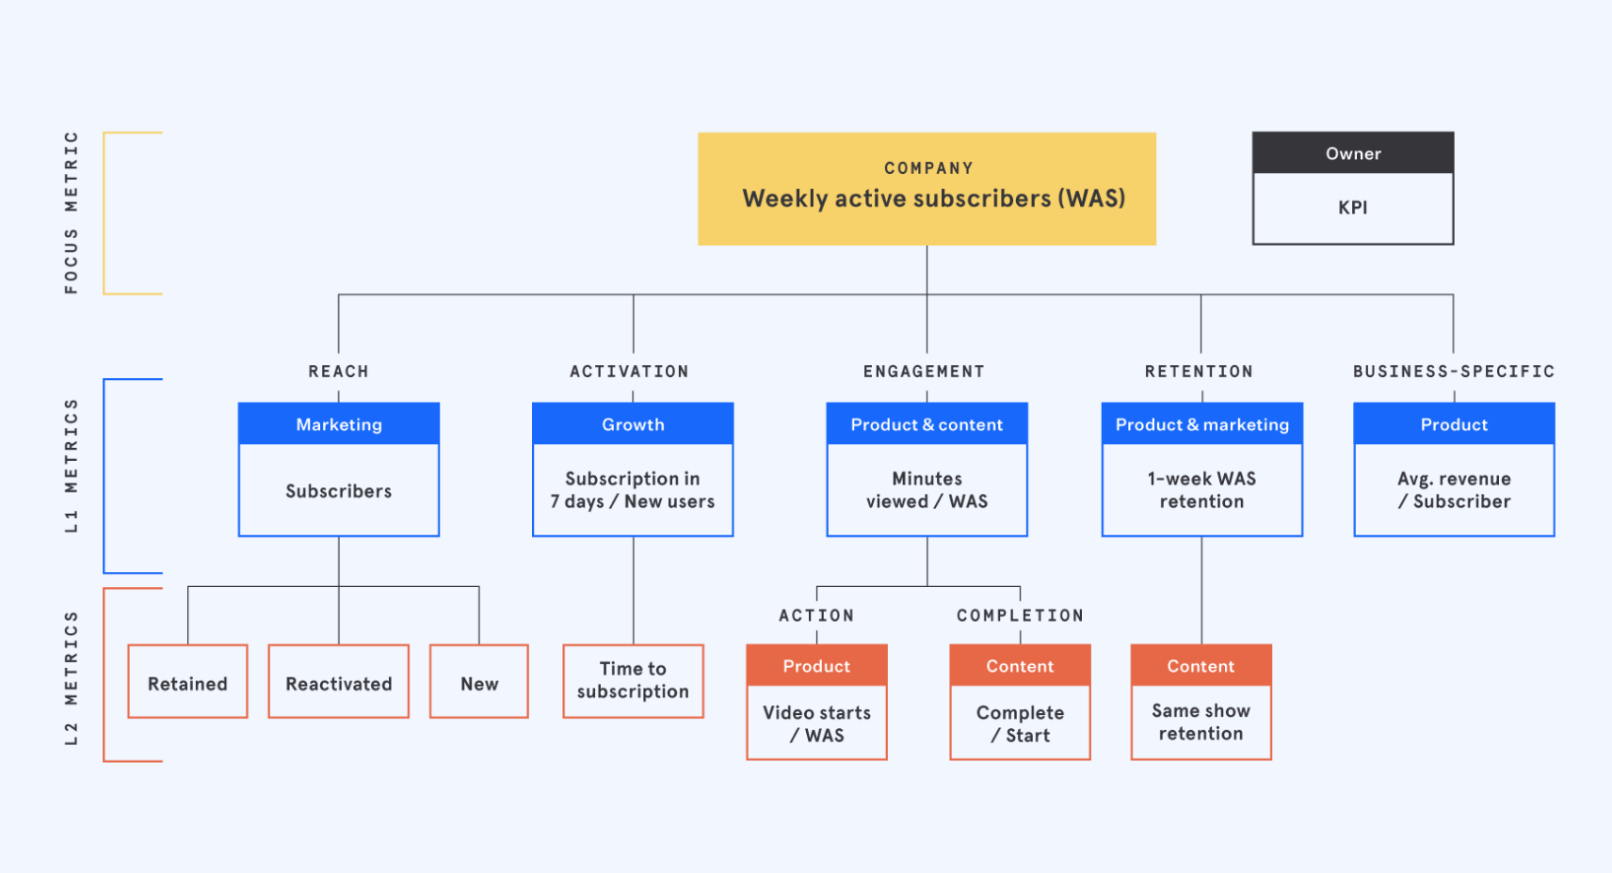

What’s a product metric interview question?

* Metric interview questions test if candidates can perform data analysis and select key metrics that matter most to the success of a product.
* Employers like Facebook and Google use these questions to evaluate critical thinking and communication skills.

There are two types of metric questions:

1. **Metric definition** based:

* Metric definition questions focus on your ability to define metrics that provide clarity on the health of a product or feature.
* Here’s an example question: “What metrics would you use to determine success for Facebook Sponsored Posts?”
* There are many different metrics you could be tracking (e.g., impressions, clicks, return on ad spend, etc.) and your interviewer will want to hear you select the most important ones using a rigorous process.

1. **Metric change** based:

* Metric change questions test if you know what to do when a key product metric (e.g., traffic, revenue, engagement, etc.) is going up or down for no apparent reason.
* This is almost the same as root cause analysis i.e.: an approach for identifying the underlying causes of an incident so that the most effective solutions can be identified and solved.

### We will be focusing on metric definition questions here -

Framework for working on such problems -

Here is how you can answer a metrics definition-based question:

1. Describe the feature.

* Explain your understanding of the feature, what problem it solves, and how it solves it.
* Clear if everyone is on the same page related to the problem and features.

1. Determine the goal of the feature.

* In a metrics question you are measuring the success of a feature in achieving a specific goal.
* Hence, it is crucial to have clarity on what that goal is.

1. Walk through the customer journey.

* Understand the funnel of the product and customer interaction.
* Walk through the user journey from beginning to the end of the interaction with the feature.
* This step also helps you think about potential behaviors that can impact the success of the feature.

1. Map and quantify user behaviors.

* Mapping user behaviors that are part of the customer journey and impact the goal of the feature in a positive or negative way.
* Examples of the customer journey phases a user can go through: Awareness, Acquisition, Activation, Engagement, Retention, Monetization, Referral. ​​
* Review the phase by highlighting various scenarios / behaviors and relevant outcomes that can have an impact on the goal(s) and explain why measuring the behaviors and (or) their outcomes is relevant.
* This step helps you determine what needs to be measured.

1. Evaluate your metrics.

* Now that you have gathered a list of metrics that impact the goal, evaluate them based on some meaningful criteria such as reach, impact, confidence, and effort.

**CASE 1:**

What metric would you look at, to improve retention for a fitness application?

________________________________________________________________

**Problem Statement:**

There’s a fitness company “PureFit”, who has launched their new application that has various fitness related information like videos and information on how to perform certain exercises, diet management plans, etc.

They also have classes and live sessions for users to join and follow.

There are two types of customers:

1. **Free customers** that have access to certain videos and information, nothing customizable.
2. **Paid customers** that can get personalized diet plans and advice from experts with respect to their fitness goals.

Here what we look at is based on our business model and user behavior.

We look at a **retained user who has been with us for at least two months.**

If they fall off before two months, then we don't call them as a retained user.

So basically, that a user has been using the app for more than two months.

Now that we have a fair idea of the problem and if we just look at the funnel for a user joining a fitness app it could be:

* There's an **acquisition stage** where we are trying to acquire the users.
* Then there’s an **onboarding stage** where users have signed up and logged in.
* Now next comes the **engagement part w**herein they're browsing what all the app has to offer i.e., they're doing the classes looking at a bunch of videos.
* Finally, if they're **coming back on the platform** again and they're continuously using it for two months that is what we are qualifying as retention.

At this stage you can clarify your understanding and if the flow you have imagined is actually correct.

**Defining relevant metric for each stage of the funnel:**

**We then need to define metrics across each state of the funnel** just to see the various touch points and checkpoints which can help us **design other strategies to boost retention.**

Retention comes pretty late in the funnel so we will try to look for drop-off points as well to handle retention or increase retention as a whole.

1. **Number of users joined / Weekly/Monthly active users (Acquisition)**

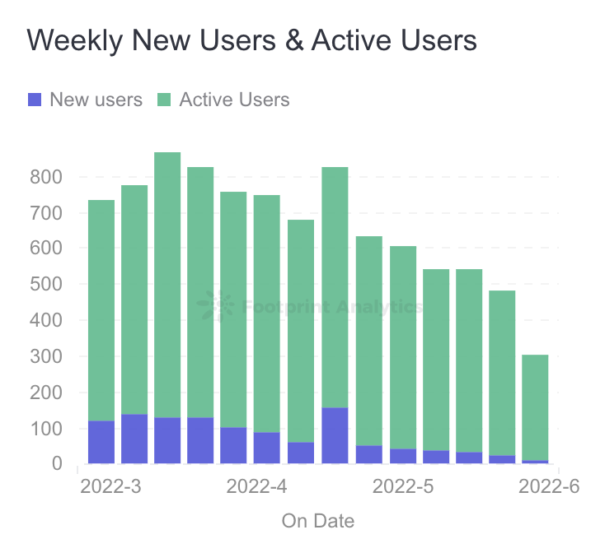

These are the very basic metrics to look at and understand and can directly get us information about the ongoing statistics of our product.

This is also the first part of our funnel i.e., getting users to join the platform.

* We want our business to grow so we always need to focus on increasing our user base actively.
* **If a company is in its growth phase the main goal can be increasing its user base and getting more people onboard.**
* We can modify our marketing strategy accordingly and for the onboarded customers we can create a notification system to encourage them to attend more classes/videos and make them more active on the platform.

1. **Retention table / Nth day retention (Engagement)**

* N-day retention simply measures how many of your users come back to your app on a particular day. We will start counting from “Day 0.”

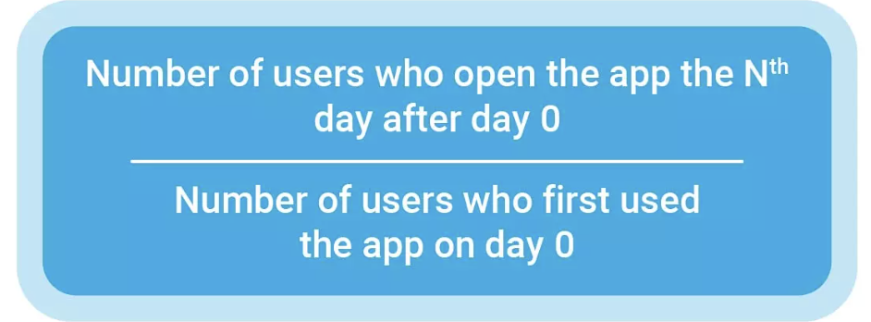

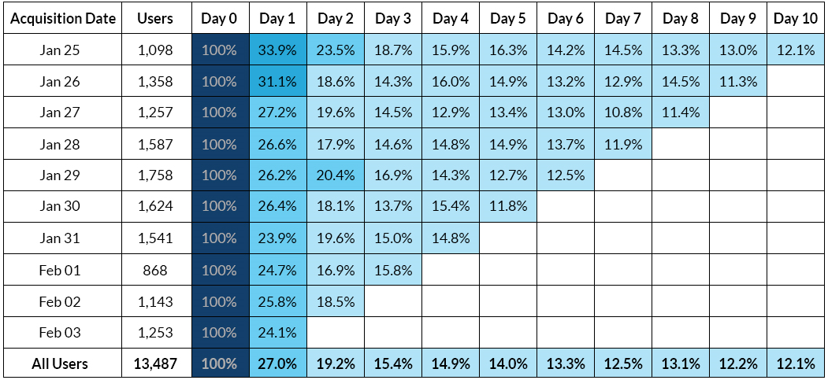

* The number of new users can be high but if the retention rate is not high, we will keep losing customers and eventually end up with a very small customer base.
* This will also give us feedback about the quality of our product or the stickiness of it.

1. **The number of classes attended / The duration of class attended (Engagement)**

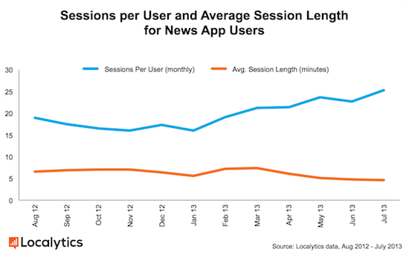

* For the engagement part, we can see the total number of classes attended by a user and their usage duration i.e., for how long the user was logged in.
* When exactly are they dropping off. For example, are they signing in and then just browsing and dropping off within 2-3 minutes. If yes, then that's feedback for us to improve our search and recommendations.
* If no. of users who attend the classes till the end is not too high, it probably means that the users are not liking the content that we are offering.
* We also need to understand what the desired level of interaction for each user is so that we can quantify and measure that it is below the desired level or around it like -
  + If it's at least once a day that's good.
  + If it's more than once a day that's super awesome.
  + If it's less than twice per week or maybe just once a week, then it's bad.

1. **Referrals and links shared / Feedbacks received**

* These may also help in understanding the level of love for the product that the customers have.
* For example, if a certain video or diet plan is shared by the users a lot with other people then we can easily identify that the people are loving it and finding it informative and useful.
* This is also important if we have a referral-based marketing strategy to onboard more people via connections and give them perks and discounts for it.
* If there is any feedback like - How was the session? How is the user communicating?
* Any sort of analysis on the feedback to understand what's going on with the user and trying to gauge whether the user will stay with us for more time or not.

**Q. Do we need to deep dive in any particular stage or reason?**

* We can look more into the content-based drop offs.

1. **Match rate between user and content (Engagement)**

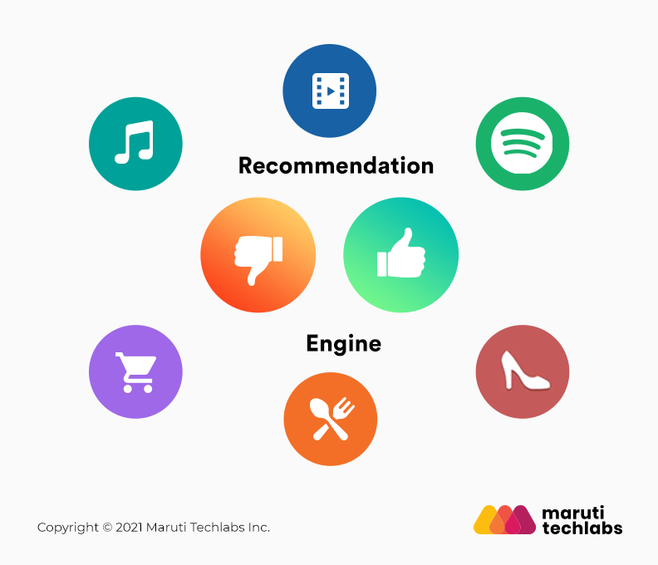

We can then look into the fact that why the user is dropping off from the class or what might be the reason for the user to not like the content.

* The very obvious reason can be the quality of the content, which we need to improve.
* The next most important thing to look at is if the user is getting what they need or they are looking for.
  + If a beginner user is looking for content of that level and is signed up for something that is very advanced for them, they will definitely be disheartened and will most likely drop off.
* It can also be a case that a person looking for Zumba is led to other activities such as yoga or weight training and they actually do not wish to do so.
  + We can have a feature inbuilt in the platform that can mark all classes and content based on different categories and segregate them for the users so that the users can actually understand the level and type of activity they are signing up for.
  + In addition to that we can bug the user upfront while signing up for understanding their intent and their expertise so that we can find and recommend a perfect match to them.

**NOTE:**

There are other metrics like free to paid user conversion percentage, that we would look at if the goal was to create a metric for success of the overall app, not just retention.

**CASE 2:**

Defining success for a banking application

________________________________________________________________

**Problem Statement**:

The “Indian Bank” which has been functional for the past 5 years and has an already established customer bank, just launched a new mobile application for its users.

**What are the success metrics you would set out to determine the success of the app?**

**Q. Do we need to look at the overall success of the bank or do we need to focus only on the success of the application?**

* We will focus on the success of the mobile app only.

Assuming that the bank is already set up and has a steady user base, we can think of two different aspects of the app, one for the new users and one for the existing ones.

The new users will have to follow an additional step of creating an account, assuming that is available via the application.

After this the funnel for user interaction and user journey will be the same for everyone i.e., different transactions and accessing different features available via the app link investments, fixed, recurring deposits loans etc., all depending on the services by the bank.

We will look into all of it, starting by dividing the metrics into two different sections:

* Revenue based metrics - because this is a bank we are looking at, the revenue is generated or directed through the mobile application itself.
  + That would help us understand the direct impact of the features and services we are providing to the users through the mobile application.
* The other aspect can be the overall user adoption or engagement.
  + This can also be categorized as non-revenue-based metrics which will help us understand if the app is user friendly and is fulfilling the expectations of the users.

1. **Revenue based metrics (Revenue) :**

To understand or calculate the revenue that the mobile app is generating, we first need to understand how the bank is itself making revenue.

We can list this information and also clarify if our information regarding the bank is valid or not.

* Credit card fees
* Checking accounts
* Savings accounts
* Mutual fund revenue
* Investment management fees
* Payment gateway fees

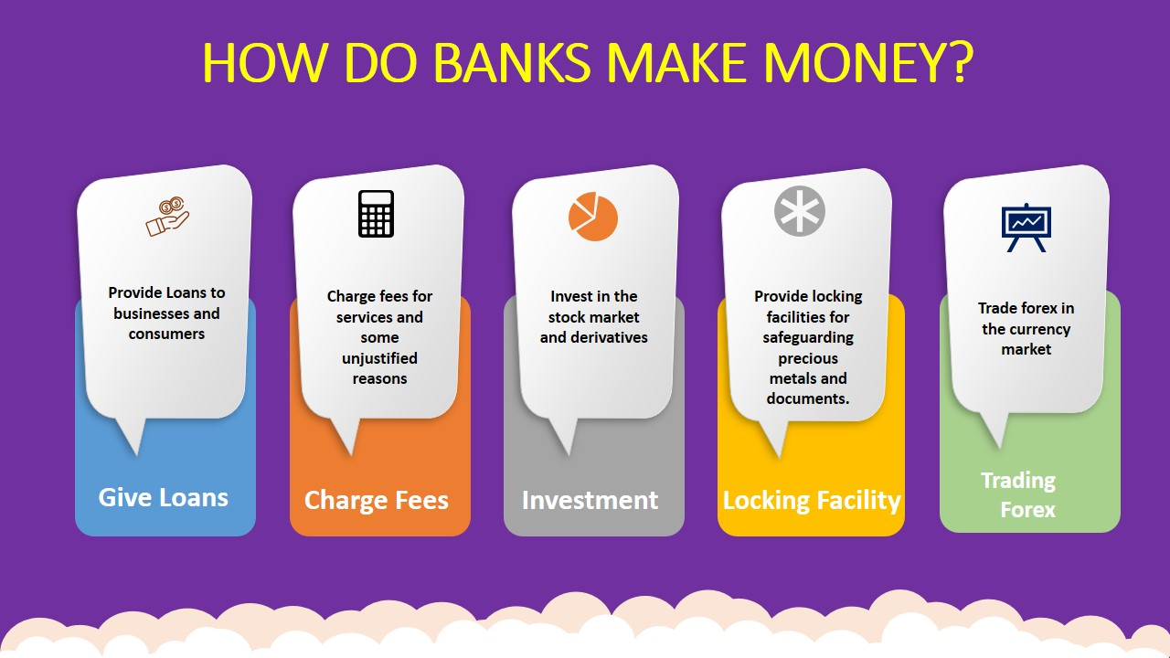

Now we can quantify out of everything what part of those revenue is being generated via the mobile app.

For example, in India, we use UPI payments and payment merchants like paytm/phonepay/gpay for payment at various places like while booking a ticket for movies via book my show website, you will be redirected to the payment application for final payment.

**Overall revenue increases due to less friction:**

There will be an increase in revenue due to ease of doing online payments and applying loans or doing investments.

Because the process has been made simpler and easier for the users, more users who did not use such features will now be a part of the increased revenue.

* For example, making payments via wallet/upi is much easier than internet banking, therefore increasing revenue.

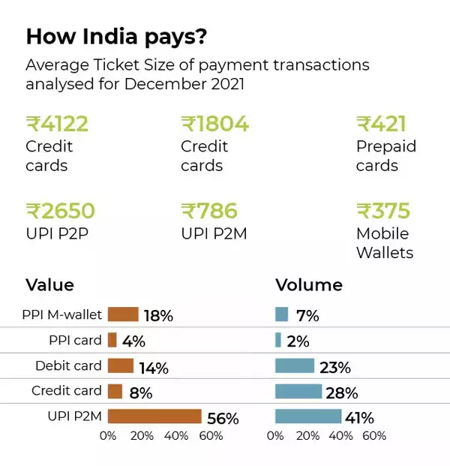

**Increase in revenue from the mobile application itself:**

For calculating the exact impact of the mobile application, we need to separate the existing revenue from the services and the revenue from the services from the mobile application. (We need to keep in mind that some of it may be cannibalized from other methods)

* We can target metrics like transactions per day, transactions per customer and total transaction value.
* We can also measure types of transactions, merchants, and purpose of the transactions to further understand and correctly take in account the type that we need for the calculation.

**Q. What percentage or ratio of transaction via mobile application would you be targeting for a successful mobile application assuming that the bank sees a shift in the industry to an online oriented one?**

* We could easily target somewhere around 80% of transactions and feature access for a successful transition of the bank to a mobile oriented goal.

1. **User adoption metrics (Adoption):**

To further understand the usage of the mobile application we need to understand the adoption of the mobile app by the users.

We can segment it into two parts:

1. Users who have ported to using mobile application.
2. New users that are joining via the mobile application.

* This will also help in future understanding the revenue that is being generated via the mobile application.
* We can measure the total mo. of accounts and the no. of accounts that are now opened via the application.
* This will enable us to understand how feasible it is and if the users are actually comfortable using the mobile application for such tasks.
* The ratio of this is what we should be looking to improve the adoption of the application for account opening and similar tasks like fixed deposits or investments, based on the services that the bank already provides.

1. **User Feedback and application records (Adoption) :**

* You need to have basic user feedback and metrics like Net Promoter Score (NPS).
  + Analyzing an organization's NPS is one of the best ways to understand the long-term growth of an organization.
* Doing sentiment analysis on user feedback would also be a great step in understanding the problems and users’ perspective about the app.
* Metrics like Abandon Rate are also really important. It is the percentage of users who started a given process within the app but did not complete it.
  + This metric helps measure how many users drop off during checkout and why they abandon their process.
* Task Completion Rate: This indicator helps to measure the user experience of a banking application.
  + It helps organizations gauge the rate at which the application solves the needs of its users.
  + Are users achieving their intended tasks? At what rate is that happening? Using this we can understand if the features of the application are failing.



